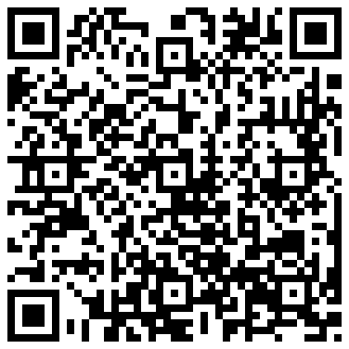
Introduction to Screencasting

Tools

http://www.cyclesoflearning.com/page4/index.php

Host Options

- You Tube
- Vimeo
- School Tube
- Teacher Tube

Time
  - Under 15 minutes

Topics

  - All topics may not be suited
  - Procedures that are regularly repeated.
  - Low level knowledge
  - Review
  - Modeling (how to write a lab report)
  - Meetings

Concerns

  - As homework?
  - Lack of Tech
  - What do I do when students don't watch.
  - But it is not perfect?

